Complete the Careers library treasure hunt
Description
The Careers library treasure hunt is a fun way to explore the Careers library whilst
considering different aspects of a variety of careers that interest you!

For this session you’ll need to use the following Unifrog tools:
- Careers library
- Locker

Why do this?
Completing this treasure hunt will help you gain a better understanding of the different aspects of careers such as which skills, degree subjects, and personality types are relevant to the line of work that you would like to go into. You will also be able to find out lots of other information related to a specific career like working hours, estimated salary and the prospective growth of that career in the coming years.

Task 1
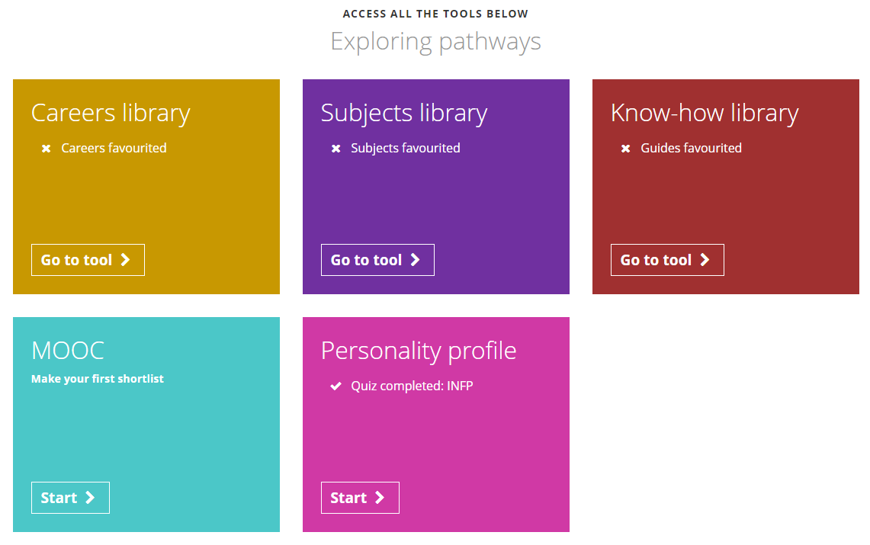
When you log in to Unifrog, click on the Careers library which is found in the Exploring pathways section:
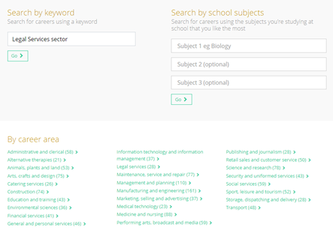
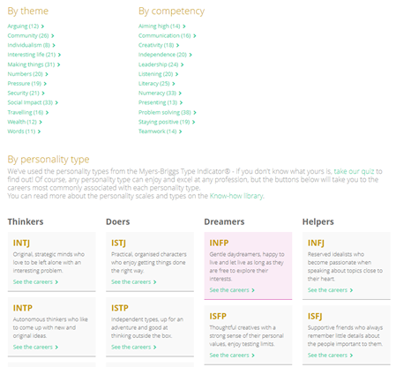
As you can see, there are lots of ways to search for careers, from telling the platform what your favourite subjects are, what your best skills are or even what personality type you have:
Using the Careers library, answer the following questions in the text box provided below and then upload it to your Locker:

1. What would be the top three career suggestions for someone who had strong argumentative skills AND was interested in the Legal Services sector?
2. What career would you recommend to someone who held strong argumentative skills AND was interested in the Management and Planning sector?
3. Watch the video for Customer services manager and answer the following:
- Name two restaurant chains that this individual has worked with
- List any two pieces of advice given by this individual, based on his experiences in this role, about getting the most out of your job.
4. If I have an INFP personality type and I’m interested in Medicine and nursing, what might be a good career for me?
5. If I want to work in financial services and be an Actuary, what are some of the subjects I would need to do a degree in order to join the IFoA?
6. Which company does Product Designer Oscar Salandin work for, and what advice does he give about Maths?
1.

2.

3.

4.

5.

6.

