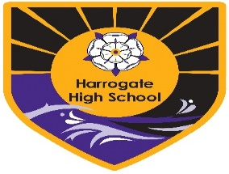
Form MM1 Parental agreement for school to administer or student to carry prescribed medicine
The school will not give your child medicine unless you complete and sign this form. Medicines will only be given as per the Harrogate High School Medicines policy. The only medicines that may be carried include Asthma Inhaler, Epi-pen or Insulin. Students must not carry any other medication in school.
Name of Student
Date of Birth
Year/VMG
Medical condition or illness
Procedures to take in an emergency
Medicine
We will never accept medicines that have been taken out of the container as originally dispensed nor make changes to dosages specified on label on parental instructions.
Name/type of medicine
Quantity received
Expiry date
Dosage and method
When to be given
Any other instructions
Side effects
We advise that asthmatic students carry their own inhaler and that school keep a spare inhaler
Student carries own inhaler Yes/No Spare inhaler in medical room Yes/No
Contact Details Name:
Daytime telephone no:
Relationship to student:
I accept that this is a service that the school is not obliged to undertake. I understand that I must notify the school of any changes in writing.
Date:

